# ­­my clinic

# Smart Appointment Booking – CRM Project

# Phase 3: Data Modeling & Relationships

* Goal: Build the data structure for the Appointment Booking System.

## 1. Standard & Custom Objects

• Standard: Contact (for reuse if needed as external users).  
• Custom:  
 - Doctor → Stores information about doctors in the clinic.  
 - Patient → Stores information about patients.  
 - Appointment → Stores booking details (date, time, doctor, patient, status).

## 2. Fields

• Doctor: Name, Specialization, Experience, Email, Phone, Max Daily Appointments.

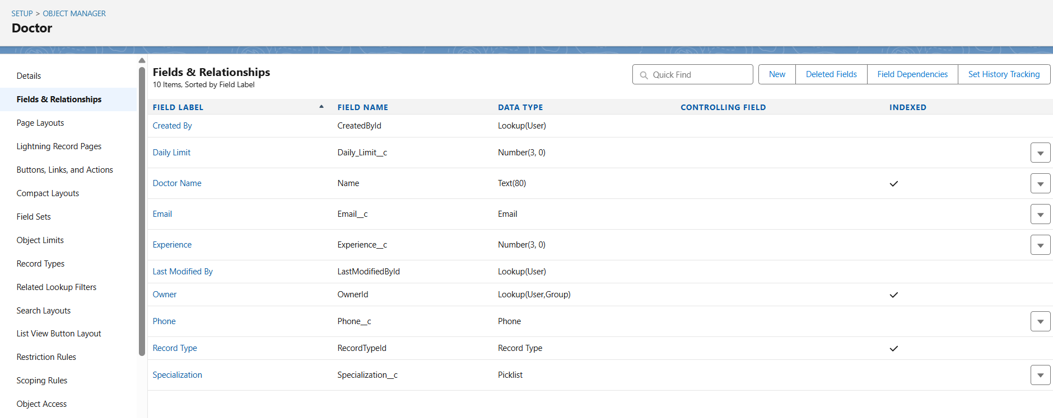

• Patient: Name, Age, Gender, Email, Phone, Linked User.

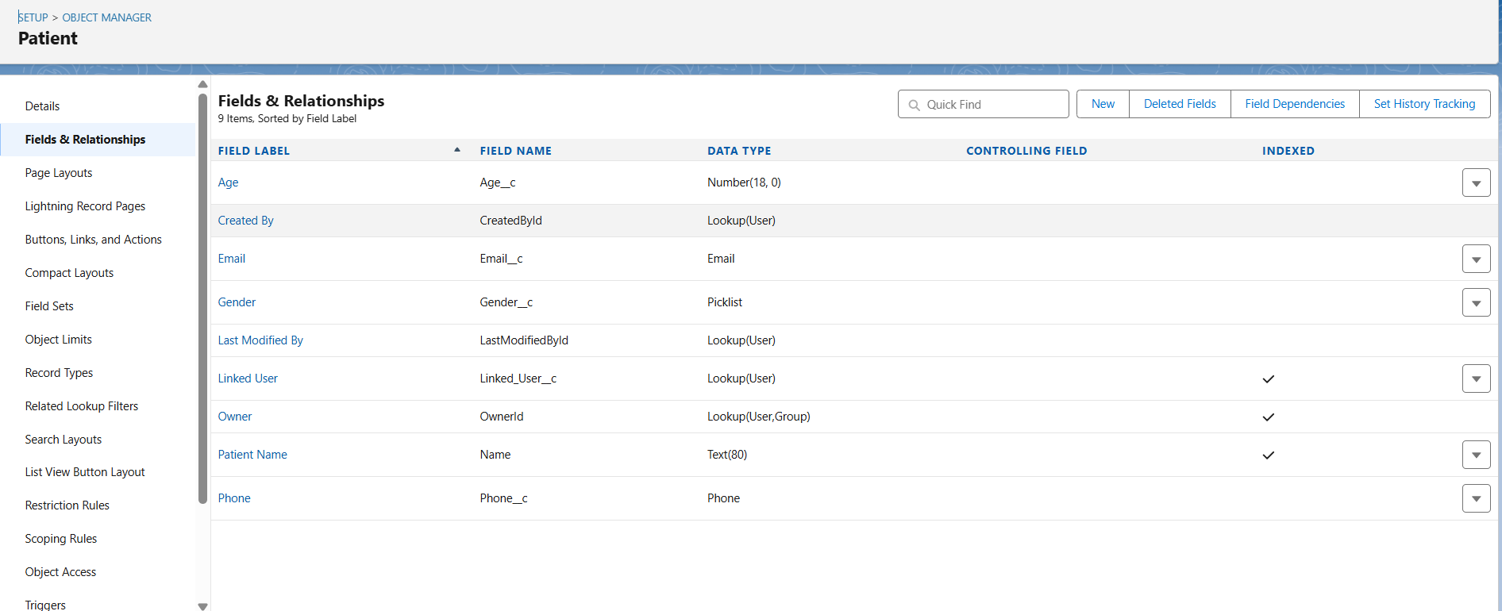

• Appointment: Appointment Number, Appointment Date, Appointment Time, Status, Doctor (Lookup), Patient (Lookup).

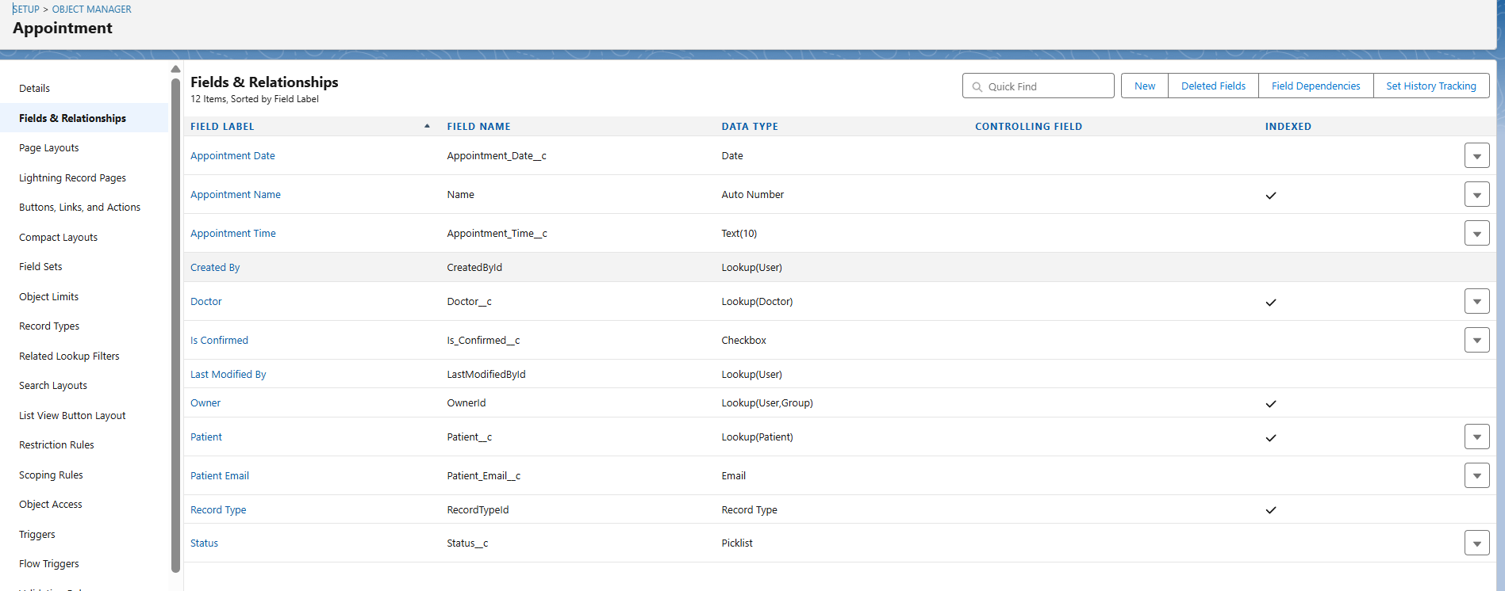

## 3. Record Types

• Doctor:  
 - General Physician → Handles general checkups.  
 - Specialist → Handles specific treatments (e.g., Cardiologist).

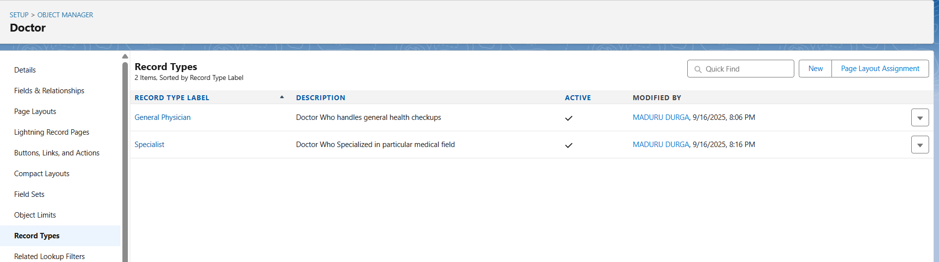  
• Appointment:  
 - In-Person Appointment → Patient visits the clinic physically.  
 - Online Appointment → Appointment done virtually (video/phone).

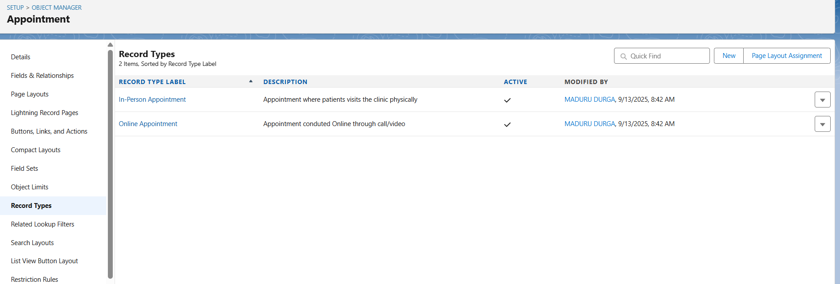

## 4. Page Layouts

• Doctor Page: Shows all doctor details + related list of Appointments.

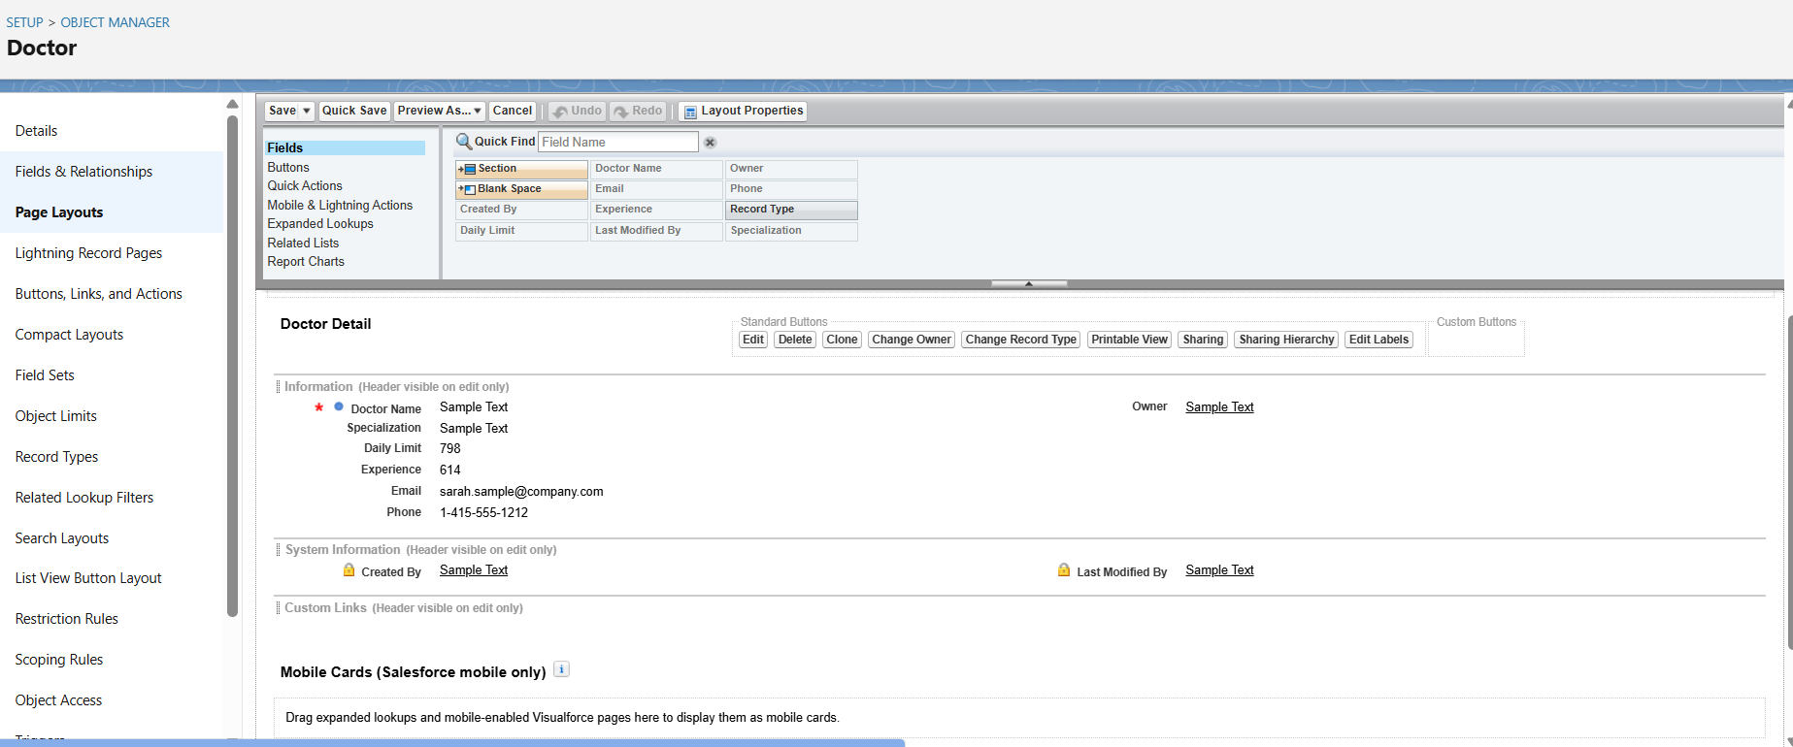

• Patient Page: Shows patient details + related list of Appointments.

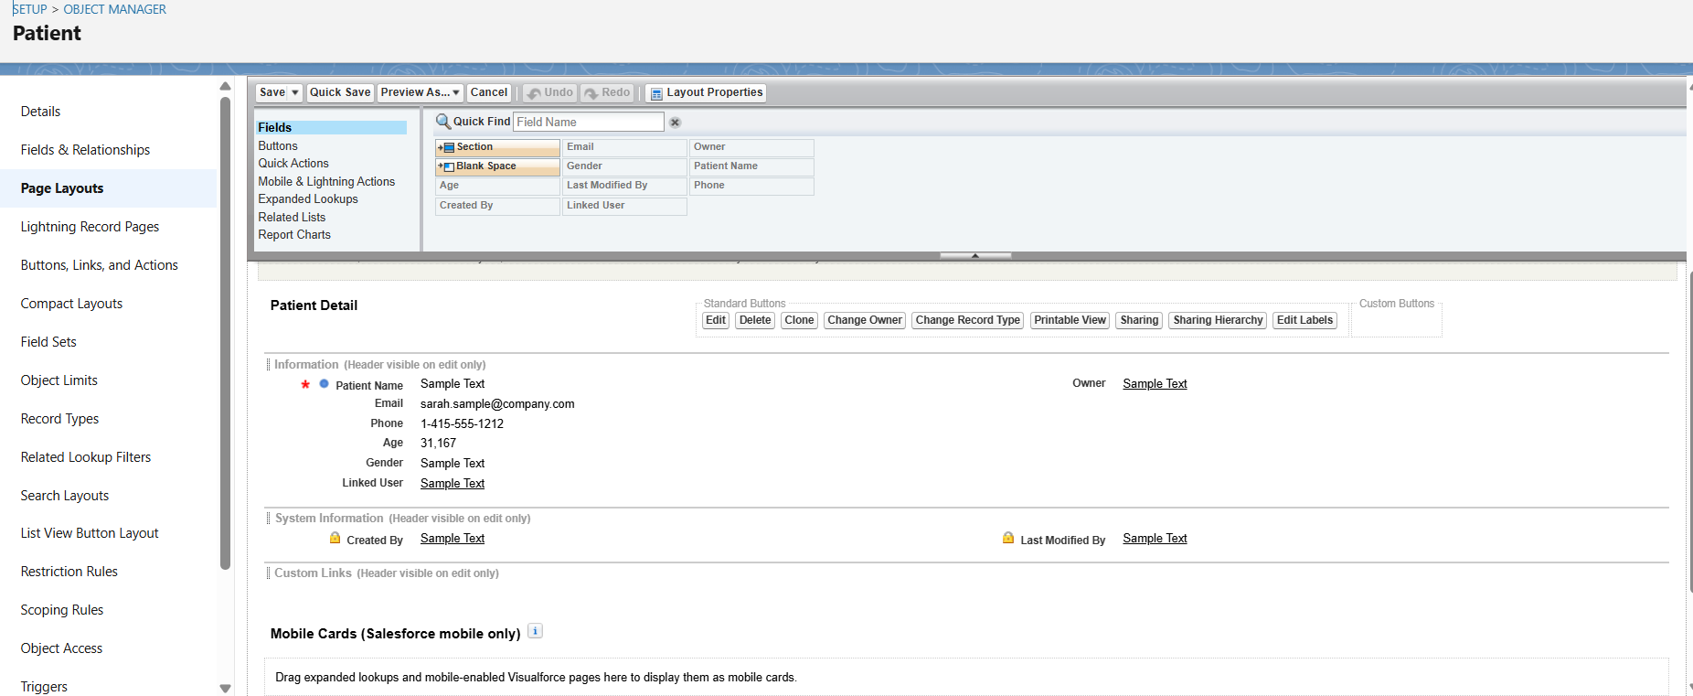

• Appointment Page: Shows booking details, with lookups to Doctor and Patient.

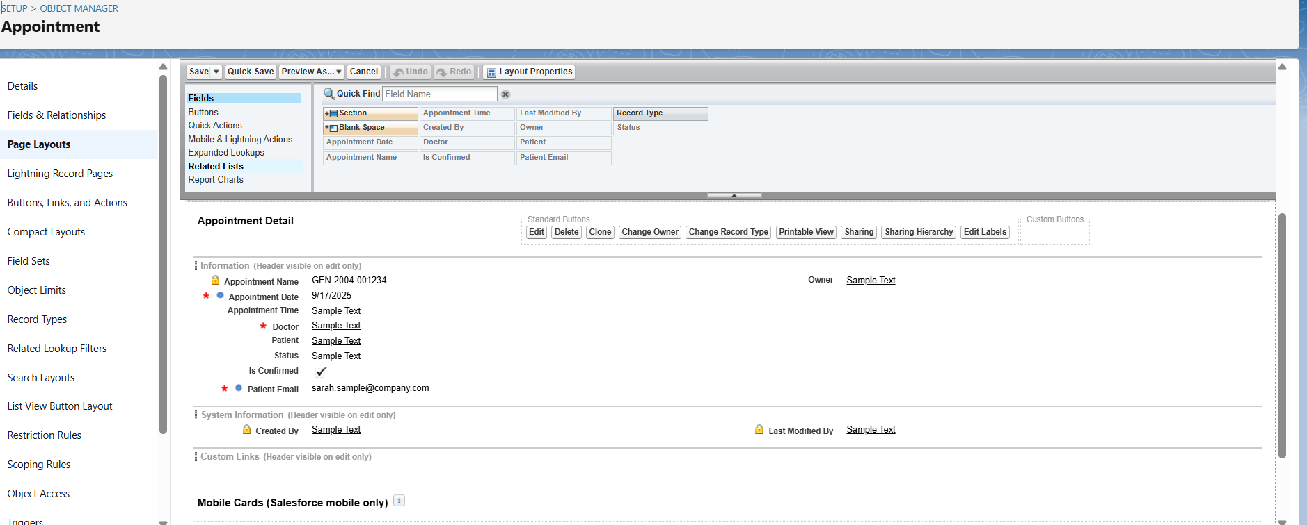

## 5. Compact Layouts

• Doctor Compact Layout: Doctor Name, Specialization, Phone, Email, Experience, Daily Limit.

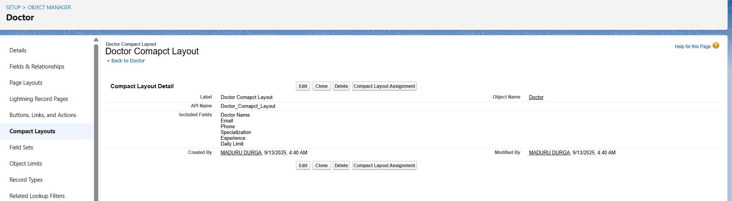  
• Patient Compact Layout: Patient Name, Age, Phone, Email.

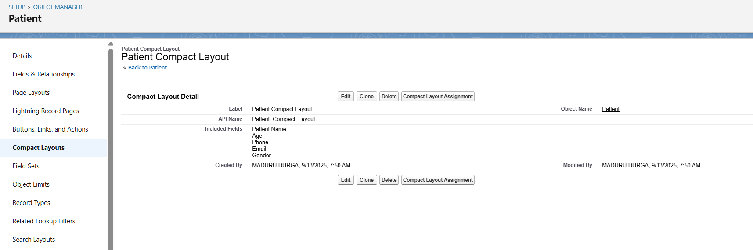  
• Appointment Compact Layout: Appointment Number, Appointment Date, Status, Doctor.

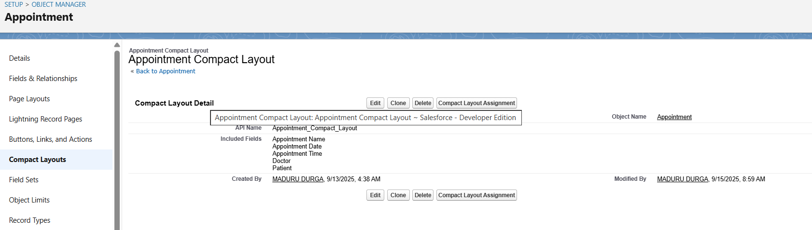

## 6. Schema Builder

• Visualized objects Doctor, Patient, Appointment with lookup relationships:  
 - Appointment → Doctor (Lookup).  
 - Appointment → Patient (Lookup).  
• Screenshot taken to show relationships for the report.

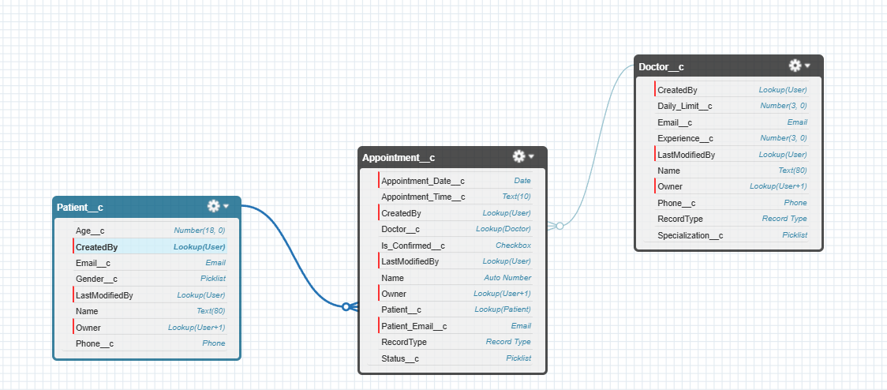

## 7. Lookup vs Master-Detail vs Hierarchical

• Appointment ↔ Doctor: Lookup (appointments reference doctors, but do not own them).  
• Appointment ↔ Patient: Lookup (appointments reference patients, but patients exist independently).  
• No Master-Detail needed because records can exist independently.  
• No Hierarchical used (that is only for user object).

## 8. Junction Objects

• Not needed in this system, because one appointment is always linked to one doctor and one patient.  
• If in future one appointment could involve multiple doctors, a junction object (e.g., Appointment Participants) would be required.

## 9. External Objects

• Not used here.  
• Could be considered in future if the clinic integrates with external systems (e.g., insurance providers or external hospital DB).